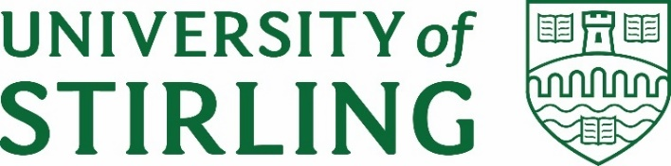
Stirling Law School’s Bulletin 3/2021
This bimonthly bulletin is for sharing Stirling Law School’s achievements in research, teaching, and engagement. In these difficult times, it’s crucial to celebrate, strengthen our sense of community, and create opportunities for cross-Faculty and cross-University collaborations. We hope you’ll enjoy this wee snippet of Stirling Law School’s recent successes.
Contents
Highlight of this issue 1
Impact and engagement 2
Publications 3
Employability News and Teaching Excellence 5
Esteem, network, and citizenship 5
Dissemination and media presence 5
Events organised 8
Get in touch 9

Highlight of this issue
The European Commission has appointed Associate Professor Guido Noto La Diega to the Expert Group on Artificial Intelligence (AI) and Data in Education and Training (the ‘Expert Group’). With the Digital Education Action Plan 2021-2027, the European Commission presented its strategic view on addressing the impact of the COVID-19 crisis, as well as the long-term digital transformation of education and training systems. Under the first priority of the Action Plan the Commission proposed to address the ethical implications and challenges of using artificial intelligence and data in education and training. As member of the Expert Group, Noto La Diega will contribute to the development of ethical guidelines on artificial intelligence and data in education and training, as well as providing advice to the European Commission’s Directorate-General for Education, Youth, Sports and Culture and Directorate-General for Communications Networks, Content and Technology. The Expert Group will have a direct impact on the future of education in the Europe, with the ambition to ensure that our sector improves in terms of performance while remaining inclusive, protective of fundamental rights, and diverse.

Impact and engagement

Wisam Abboud has been appointed to the Law Society of Scotland’s Competition Law Committee. Competition Law alongside WTO Law are Sam’s areas of specialism. Sam joins the committee at an important time. First, a number of important consultations are in the offing on which this committee intends to comment including on commercial agreements/block exemptions, merger policy, and the competition intersection with IP/Platforms (to name but a few). Secondly with the EU-UK agreement, some things that were governed by competition law (mainly state aid) are now effectively WTO Law+ but will still be covered by the Competition Committee. As Sam understands it, he will be one of two people on the committee with WTO expertise.

Further to its formation last year, the Nigerian Group on Private International Law held its inaugural programme on Monday 21 June 2021 Dr Pontian Okoli made a presentation: “The Prospects of Ratifying Hague Conventions in Nigeria – A Comparative Interrogation”. The event attracted very important stakeholders including the Secretary General of the Hague Conference on Private International Law who gave the opening remarks. Eminent academics, including Professor Paul Beaumont, also attended and provided key insights. A major aim of the NGPIL is to persuade the Nigerian government to ratify Hague Conventions. Currently, Nigeria has not ratified any of the Hague Conventions and is not a member of the Hague Conference. There is hope that the Nigerian government will be persuaded to do both eventually.

Dr Dave McArdle’s two written submission to the Department of Culture, Media and Sport inquiry into sport-related concussion have now been published, all submissions and other evidence are available here

On 6 May 2021 Professor Paul Beaumont gave an invited address to the Northern Irish judges (including their Chief Justice) through their Judicial Studies Board on the implications of Brexit for private international law in Northern Ireland which provoked a lot of questions from the judges during and after the videoconference.
On Monday 24th May, Guido Noto La Diega spoke at the “Future of AI and IP Framework Roundtable” organised by the Intellectual Property Office, the Alan Turing Institute, and the Office for AI (joint unit of the UK Government’s Department for Business, Energy & Industrial Strategy, and Department for Digital, Culture, Media & Sport). One of few nationally recognised experts in AI and Intellectual Property (IP), Guido called for the UK Government to take the lead on the international stage for an inclusive, balanced, and evidence-based IP governance of AI.
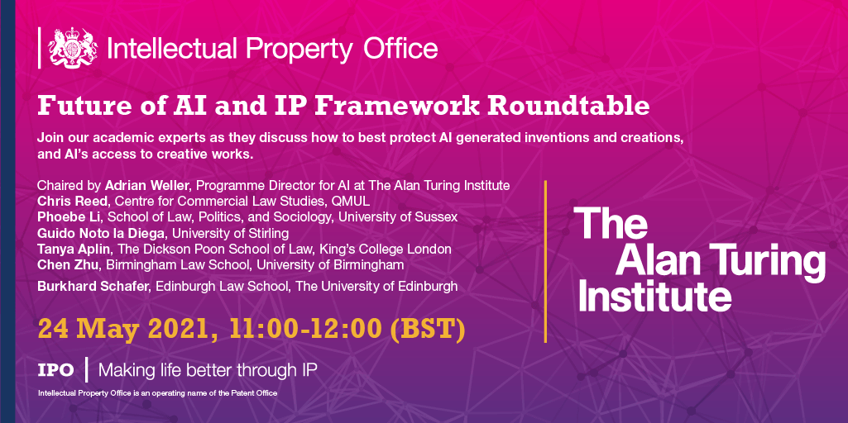

As a consequence of this event, Guido has been included in the key stakeholder list of any upcoming engagement opportunities of the Office for AI and the AI Council. The AI Council is an expert committee that provides advice to the UK Government and high-level leadership of the AI ecosystem.

Publications

Annalisa Savaresi and Lucia Perugini, ‘Balancing Emissions and Removals in the Land Sector: The View from the EU’ (2021) 15 Carbon & Climate Law Review 49
- This article paints a picture of the status quo and of the ongoing debate concerning new measures that the EU may adopt in the near future, in order to balance emissions and removals in the land sector.
Annalisa Savaresi, ‘Plugging the Enforcement Gap: The Rise and Rise of Human Rights in Climate Change Litigation’ <http://www.qil-qdi.org/plugging-the-enforcement-gap-the-rise-and-rise-of-human-rights-in-climate-change-litigation/>
- This issue of Questions of International law edited by Dr Savaresi in reflects on the increasing use of human rights arguments and remedies in climate litigation
Annalisa Savaresi and Margaretha Wewerinke-Singh, ‘Friends of the Earth (Netherlands) v Royal Dutch Shell: Human Rights and the Obligations of Corporations in the Hague District Court Decision –’ (GHNRE, 31 May 2021)
- This blogpost considers the role of human rights made in the landmark ruling of the Dutch Courts in the climate case brought again Royal Dutch Shell
Harro van Asselt and others, ‘Shell-Shocked: A Watershed Moment for Climate Litigation against Fossil Fuel Companies’ (CCEEL, 28 May 2021)
- This blogpost provides an early analysis of the landmark ruling of the Dutch Courts in the climate case brought again Royal Dutch Shell
Annalisa Savaresi and Lucia Perugini, ‘Sinks, Reservoirs of GHGs and Forests’ in Leonie Reins and Geert van Calster (eds), The Paris Agreement on Climate Change (Edward Elgar Publishing 2021)
- This book chapter considers the international obligations concerning emissions from land uses enshrined in the 2015 Paris Agreement
Annalisa Savaresi, ‘Inter-State Climate Change Litigation: “Neither a Chimera nor a Panacea”’ in Ivano Alogna, Christine Bakker and Jean-Pierre Gaucci (eds), Climate Change Litigation: Global Perspectives (Brill Nijhoff 2021)
- This book chapter considers the prospects of inter-state climate litigation.

Paul Beaumont published the first article in the April issue of the Journal of Private International Law as a culmination of the AHRC project on Private International Law in the UK after Brexit for which he was the Principal Investigator:
P Beaumont, ‘Some Reflections on the Way Ahead for UK Private International Law after Brexit’ (2021) 17(1) Journal of Private International Law 1-17.
Dr Jayne Holliday and Paul combined to write a provocative paper on habitual residence building on case law in the leading Supreme Courts in the world and on the work of the Hague Experts’ Group on Family Agreements in Paul Beaumont and Jayne Holliday, ‘Habitual residence' in child abduction cases: Hybrid approach is now the norm but how much weight should be given to parental intention?’ (Stirling Law Working Papers 2021/1). The final version is to be published in M Pfeiffer, J Brodec, M Zavadilová, P Bříza (eds) Liber Amicorum Monica Pauknerova (Wolters Kluwer, 2021).

Employability News and Teaching Excellence
Elaine Watson (Employability and Skills Officer) was highly commended at the peer-led Teaching Impact Awards for the team effort behind the Putting Arts & Humanities to Work Module. Elaine and Guido Noto La Diega were also among the individual nominees, congrats!

Stirling law graduate Caroline Crawford was awarded a joined prize as winner of the Dee Amy-Chinn Prize for Gender & Feminist Studies for her undergraduate dissertation titled ‘Evaluating the Success of the Domestic Abuse Bill in bringing England to Compliance with Obligations under CEDAW Convention’ supervised by Dr Damian Etone

Congratulations to Louise Newstead on the MSc programme in Human Rights & Diplomacy who has been offered an internship with the International Anti-Corruption Academy (IACA).

Esteem, network, and citizenship

Hong-Lin Yu has been promoted to Professor, well-deserved!

Great to see Stirling Law School staff nominated at the Research Culture Awards 2021 for Best Professional Support (Pauline Darnbrough), Best Research Leadership (Hong-Lin and
Guido Noto La Diega), and Best Collaborator (Hong-Lin). Bravo! #StirRCAwards21

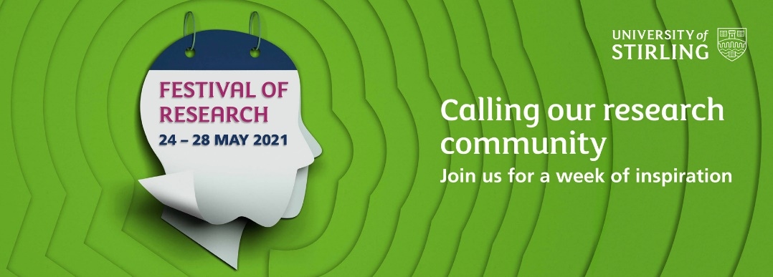

Dissemination and media presence
On 11 June 2021, Paul Beaumont gave a major talk to a large international audience assembled for the AMICABLE final conference (hosted in Berlin but delivered by videoconference) on the work of the Experts’ Group on Family Agreements involving Children at the Hague Conference on Private International Law. Paul is the Chair of the Experts’ Group.
Dave McArdle spoke at an international sports law summer school hosted by Rijeka University on sports disciplinary tribunals and ECHR Article 6 (publication to follow)
Dr Jayne Holliday presented her paper on ‘The age of marriage in Scotland and its international implications’ at the Legal History in Modern Practice Conference on Saturday 23rd May 2021.
Annalisa Savaresi has co-organised and presented her research in the following workshops:
- Workshop “Climate Change Litigation and Human Rights Arguments: Stocktaking and a Look at the Future” 6-7 May 2021
Co-organisers (Annalisa Savaresi, Joanne Scott, EUI and Mariagrazia Alabrese, Sant’Anna)
- Workshop: International human rights courts and bodies at the edge of the climate tipping point 09.06.2021 – 10.06.2021
Co-organiser Annalisa Savaresi (Basak Cali, Hertie) Joana Setzer (LSE) and Cesar Garavito (NYU)
- Workshop: Glasginburgh 2021 International Law and Distribution: Sustainable Development, Security and Governance of Resources 13-14.05.21
Additionally, Annalisa has given talks at the following events:
- Copenhagen University Climate Breakfast Seminar Series: The role of human rights in the climate emergency 28 May 2021
- CCLR event Getting to Zero: Climate Change Mitigation and Land Use 7 June 2021
- FIDH Corporate Accountability for Human Rights Abuses: FIDH Launches Updated Guide for Victims and NGOs on Accountability and Redress Mechanisms 18 June
SAGE experts Christina Pagel and Stephen Reicher, the Wellcome Trust’s Head of Population Health Mary De Silva, human rights lawyer and former shadow attorney general Baroness Shami Chakrabarti, and Stirling Law School's Guido Noto La Diega are among the signatories of a letter calling on Prime Minister Boris Johnson to support an Intellectual property waiver on COVID-19 vaccines and treatments. The campaign led by Global Justice Now was covered by major news outlets including Sky News, Daily Mail, and Reuters
Guido presented “Remote learning and digital wellbeing: data protection and copyright issues” with Dr Giulia Priora (Sant’Anna School of Advanced Studies, Pisa) at the 141st Nexa Wednesday organised by the Nexa Center for Internet & Society, University of Turin. Guido and Giulia discussed the legal implications of adopting US-based platforms for remote teaching purposes. You can read the key findings, watch the video, and download the slides here. The event was covered by mainstream Italian media including La Stampa.
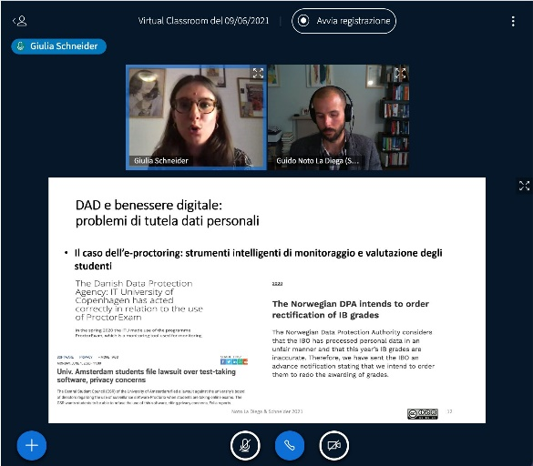
Additionally, Guido gave the following talks:
- ‘The Tragedy of the Internet of Things (You Don’t Own). Intellectual Property, Private Power, and Digital Serfdom’ (PGR Summer School “Owning the Land: from Private Property to Commons”, University of Palermo & Strathclyde University, Palermo, 17 June 2021) – a panel with Professor Rowan Cruft
- “Presentazione del libro Internet of Things and the Law di Guido Noto La Diega” (Juridical Observatory on Digital Innovation - Osservatorio giuridico delle innovazioni digitali, University of Rome “La Sapienza”, 26 May 2021)
- ‘Intellectual Property and the Internet of Things’ (MA in International Relations – Path of Excellence, University of Palermo, 21 May 2021)
- ‘The crisis of property and user empowerment in the Internet of Things’ (TILTing Perspectives 2021, 19-21 May 2021)

Events organised
On 22 June 2021, a videoconference workshop on ‘Cross-border families under Covid-19’ attracted a very large international audience hosted by the Minerva Center for Human Rights, Tel Aviv University. Paul was a member of the organising committee and chaired the session in which papers were given by Professor Rhona Schuz on international child abduction cases during the Covid pandemic and Nofar Yakovi Gan-Or on the problems facing cross-border childbirth during the pandemic.

The Royal Society of Edinburgh Research Network SCOTLI (Scottish Law and Innovation Network) invites you to the following talks:
- On 26th August at 2pm, Janis Wong (PhD student at St Andrews) will give an (en)lightening talk on “Online Learning as a Commons: Supporting the co-creation of data protection solutions through a collaborative digital environment”
- On Monday 27th September 2021 at 5pm, Professor Pamela Samuelson (Richard M. Sherman Distinguished Professor of Law at Berkeley Law School and Co-Director of the Berkeley Center for Law & Technology) will give a lecture on “Copyright and open innovation: fair use and software copyright after Google LLC v. Oracle Am., Inc. [2021]”
- On Monday 11th October 2021 at 1pm, Professor Willajeanne F. McLean (Distinguished Professor of Law, University of Connecticut) will present “The Power of Words: The Contradictory Stories Trademarks Tell” a talk on race and trade marks
- On 28th October 2021, Zihao Li (PhD student, University of Glasgow) will talk about “Data Protection Law and Online Personalised Pricing” (discussant: Guido Noto La Diega)
- On Monday 22nd November 2021 at 4pm, Dr Andrew Gilden (Assistant Professor of Law at Willamette University) will present “Patenting pleasure” a talk about US patents that cover various forms of sex technologies. Andrew will take a critical, queer theoretical approach to patent law
- On 27th January 2022, Enenu Okwori (PhD student, University of Aberdeen) will present “Obligation of states to seek assistance where they are unable to prevent an armed attack from within their territory”
Please email Guido to book your (virtual) place

Get in touch
If you would like to contribute or suggest anything for future bulletins, please get in touch with Guido.

