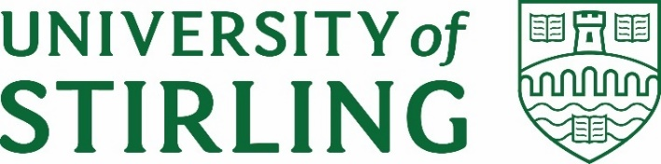
Stirling Law School’s Bulletin 4/2021
This bimonthly bulletin is for sharing Stirling Law School’s achievements in research, teaching, and engagement. In these difficult times, it’s crucial to celebrate, strengthen our sense of community, and create opportunities for cross-Faculty and cross-University collaborations. We hope you’ll enjoy this wee snippet of Stirling Law School’s recent successes.
Contents
Highlight of this issue 1
Impact and engagement 1
Publications 3
Employability News and Teaching Excellence 4
Esteem, network, and citizenship 4
Dissemination and media presence 6
Events organised 8
Get in touch 8

Highlight of this issue
The University of Stirling is the first university in Scotland to join the Pan-European Seal, a prestigious partnership with Europe's leading Intellectual Property offices. Thanks to the Pan-European Seal our students will access an abundance of traineeship and learning opportunities. Under this scheme, our university will work closely with the European Patent Office and the European Union Intellectual Property Office to bridge the gap between academia and the intellectual property labour market. Thanks to Guido Noto La Diega, Neville Wylie, Lee Zhuang, Alison Green, Dave McArdle and everyone at the University of Stirling for supporting the process and making this partnership possible!

Impact and engagement
Environmental Standards Scotland formally launched on 1st October 2021 to ensure Scotland’s communities can enjoy the healthy environment that they deserve. The launch event, hosted by BBC presenter Clare English, featured a welcome from the Chair Jim Martin, an overview of ESS from our Interim CEO Brendan Callaghan, and a panel discussion which included our very own Dr Annalisa Savaresi, who is a Board member of ESS.
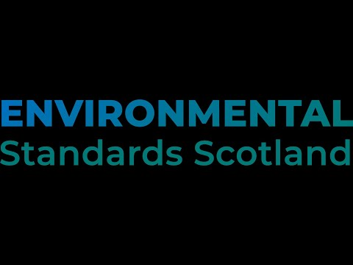
On 14 and 15 September, Professor Paul Beaumont chaired the 5th meeting of the Experts' Group on Family Agreements involving children where there is an international element, at the international organisation responsible for the progressive unification of private international law rules (the Hague Conference on Private International Law - HCCH). The Experts' Group made good progress on developing a practitioners' guide on how the existing HCCH Conventions can be used to facilitate the recognition and enforcement of family agreements involving children across international borders.
From 11-15 October, Paul was a member of the EU delegation at the HCCH Working Group on Jurisdiction trying to develop an instrument, which would be binding in public international law for those States who ratify or accede to the instrument, regulating parallel proceedings between the same parties relating to the same subject matter in more than one State in civil or commercial matters.
In July 2021, the House of Lords and the House of Commons established the Joint Committee on the Draft Online Safety Bill with the aim to consider the UK Government's draft Bill to establish a new regulatory framework to tackle harmful content online. Guido Noto La Diega, on behalf of the British Irish Law, Education and Technology Association (BILETA) gave written evidence with Dr Kim Barker (Open), Ruth Flaherty (Suffolk), and Aysem Diker Vanberg (Greenwich). In their submission, published on the UK Parliament’s website in September 2021, Guido and the other BILETA members expressed some serious concerns over the Draft Online Safety Bill, both in terms of its substantive aim, and its likely practical implications.

Publications
In August 2021, Dr Jayne Holliday and Professor Paul Beaumont submitted a very substantial edited book to Hart Publishing for the Hart Studies in Private International Law Series. They have been working on this book for more than 2 years as editors bringing together over 50 contributors from all over the world to produce a state of the art, comprehensive Guide to Global Private International Law. The book has been accepted by Hart and will be published in April 2022. It contains 41 Chapters. Paul is the co-author of 8 chapters and Jayne is the co-author of 5 chapters.

EJIL TALK: The UN HRC recognizes the right to a healthy environment and appoints a new Special Rapporteur on Human Rights and Climate Change. What does it all mean?, a talk by Dr Annalisa Savaresi

Guido Noto La Diega has co-authored the report “Expanding Business Thanks to Data Economy: IP as a Tool” with Dominique Guellec (Haut Conseil de l'évaluation de la recherche et de l'enseignement supérieur, Paris) and Aurelio Lopez-Tarruella (Profesor Titular de Derecho internacional privado, Universitat d’Alacant). You can download the report here. Media coverage included IP Tango, IPKat, and Eventos Juridicos.
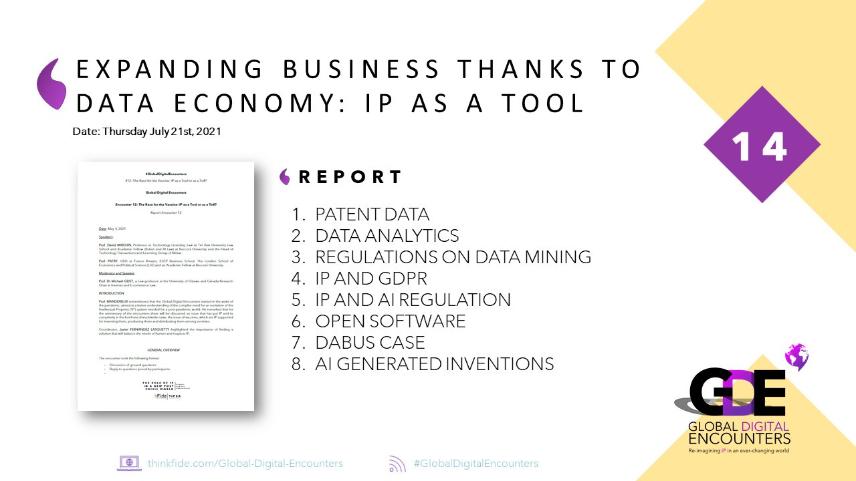
Guido’s paper ‘Artificial Intelligence and Databases in the Age of Big Machine Data’, originally published in (2019) 25 AIDA 2018 93-149, was translated into Russian by Dr Daria Motovilova and appeared as ‘ИСКУССТВЕННЫЙ ИНТЕЛЛЕКТ И БАЗЫ ДАННЫХ В ЭПОХУ БОЛЬШИХ МАШИННЫХ ДАННЫХ’ in M.A. Rozhkova (ed), The Law of the Digital Economy – 2021 (CTATYT, IPClub 2021) 90

Employability News and Teaching Excellence
Dr Pontian Okoli delivered a lecture at the invitation of the Max Planck Institute for Comparative and International Private Law. The lecture, "Negotiating the Enforcement of Obligations: A Comparative Appraisal of Legal and Institutional Impediments", examined how the African Continental Free Trade Agreement and the Hague Judgments Convention have front-loaded the need to address challenges that undermine the enforcement of obligations in Africa.

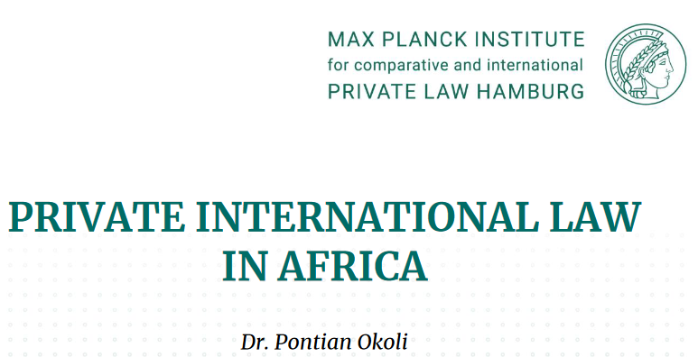

In the last issue, we forgot to mention that Julia Whytock was nominated at the RATE awards in the following categories: Excellence in teaching in the Faculty of Arts & Humanities; Fantastic Feedback Award; Best Tutor Award.

Esteem, network, and citizenship
Associate Professor Dr Katie Boyle is in Oxford for the semester working on research. She has been appointed visiting research fellow at the Bonavero Institute of Human Rights (University of Oxford, Faculty of Law, Magdalen College) where she will be working on
Nuffield Foundation researching the justice gap in access to effective remedies for social rights violations. More info here.
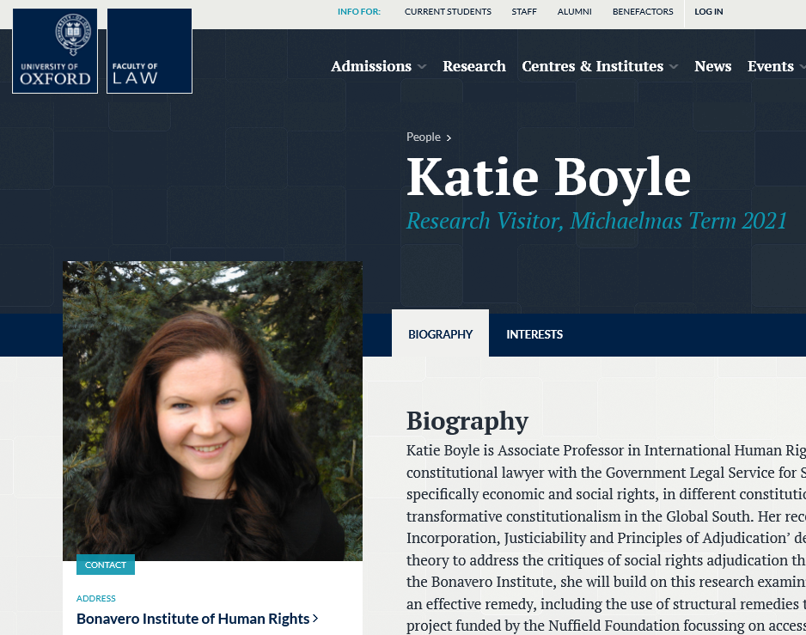

Dr Pontian Okoli has been appointed as the Chair, Academy and Mentorship Committee of the recently established Indonesia International Arbitration Center. Members of the Advisory Board include Ben Giaretta (Chair, London Branch of the Chartered Institute of Arbitrators) and Professor Maxi Scherer (Queen Mary University of London).

Dr Dave McArdle has accepted an invitation to serve on the advisory board for the new Sports Law and Administration research cluster (SLAC) at the University of Limerick. The aim of SLAC is “to highlight the research of individuals who are currently working in silos and by creating an identifiable research cluster. It will highlight existing research and provide a forum for collaboration in the form of research projects and funding applications. The governance structure will include international experts and will result in the synergy of existing research and provide opportunities for exploring other areas” which includes international collaborative projects and grant applications. In addition to providing advice and assistance, Dave will be asked to give a guest lecture every year.

Assoc Prof Guido Noto La Diega has been appointed knowledge partner of the Women 20 (W20) UK Delegation. The Women 20 (W20) is an official G20 engagement group established during the Turkish presidency in 2015. It is a policy recommendation engagement group which is part of the G20 process but is independent from governments. Its primary objective is to ensure that the gender considerations are mainstreamed into G20 discussions and translate into the G20 Leaders' Declaration as policies and commitments that foster gender equality and women’s economic empowerment.

Guido has also spent reading week in Italy as Visiting Professor of Comparative Privacy Law at the University of Trento, ranked first among the medium sized universities in Italy. In that context, Guido has also delivered a public lecture on “Internet of Things and the Law: Curbing Data Power through Access?” (Find below a picture depicting one of Guido’s mysterious gestures)

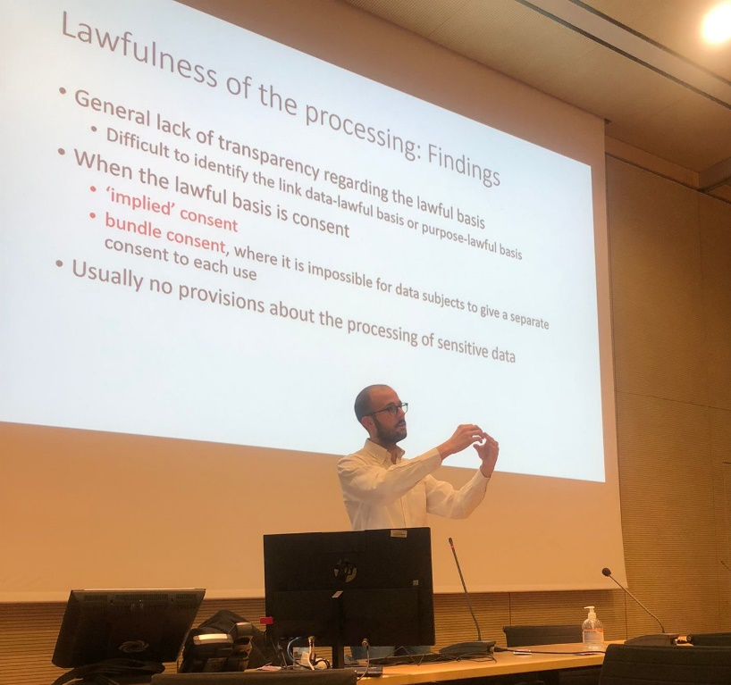

Dissemination and media presence
Dr Domenico Carolei won one of the best paper awards, sponsored by Routledge, at the International Conference "Questions of Accountability: Prerogatives, Power and Politics" hosted by the University of Worcester, where keynote speeches have been given by leading figures, including Baroness Hale.
Dr Dave McArdle gave a keynote at a conference on Caribbean Sports Law at the University of the West Indies, Mona last month. It was on the global implications for sports disciplinary tribunals of some recent ECHR decisions.
On Monday 6 September, Dr Jayne Holliday presented an interdisciplinary paper at the University Association for Contemporary European Studies Conference on 'EU External Competence in relation to recognition of non-EU divorces' with Dr Cleo Davies of the School of Social and Political Science, University of Edinburgh.
On 12-14 September, Dr Annalisa Savaresi spoke at the workshop "Climate & Changes: Legal and Ethical Implications", organised by Sant'Anna School of Advanced Studies, Italy
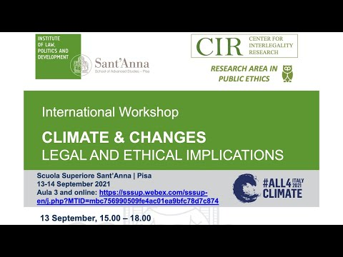
On 30 September, Annalisa gave the closing keynote at the event COP26, Climate Change and Human Rights’ organised by the Law Society of Scotland
In September, she also spoke at Greenpeace event Demanding Accountability through Climate Litigation A Snapshot of Cases and Current Developments; and at the event Framework instruments and human rights treaties: insights from experience, University of Dundee
To watch her interview to NBC Inside Climate click here
Guido Noto La Diega has presented their research at the following events:
- ‘Fourth Industrial Revolution and European Intellectual Property Law’ (Intellectual Rights: Challenges of the 21st Century, Tomsk State University, 9-13 November 2021)
- (with Rossana Ducato) ‘Questioni aperte in tema di diritto d’autore e privacy nell’Internet delle piattaforme per la didattica a distanza’ (AISA VI convegno annuale “La borsa e la vita. Scienza aperta e pandemia”, Palermo, 14 October 2021)
- ‘Il diritto ad accedere alla scatola nera degli agenti artificiali’ (L’errore nella decisione nell’era dell’intelligenza artificiale, Università di Macerata, 24 September 2021)
- ‘Death Becomes HE: The Rise of Lecture Capture in the Panopt(ic)o(n)’ (Gikii 2021: The Light at the End of the Vaccination Syringe Edition, 13-14 September 2021)
- ‘Zooming in on Copyright in Remote Teaching: A Socio-Legal and Comparative Study’ (112th Annual Conference of the Society of Legal Scholars, Durham University, 2 September 2021)
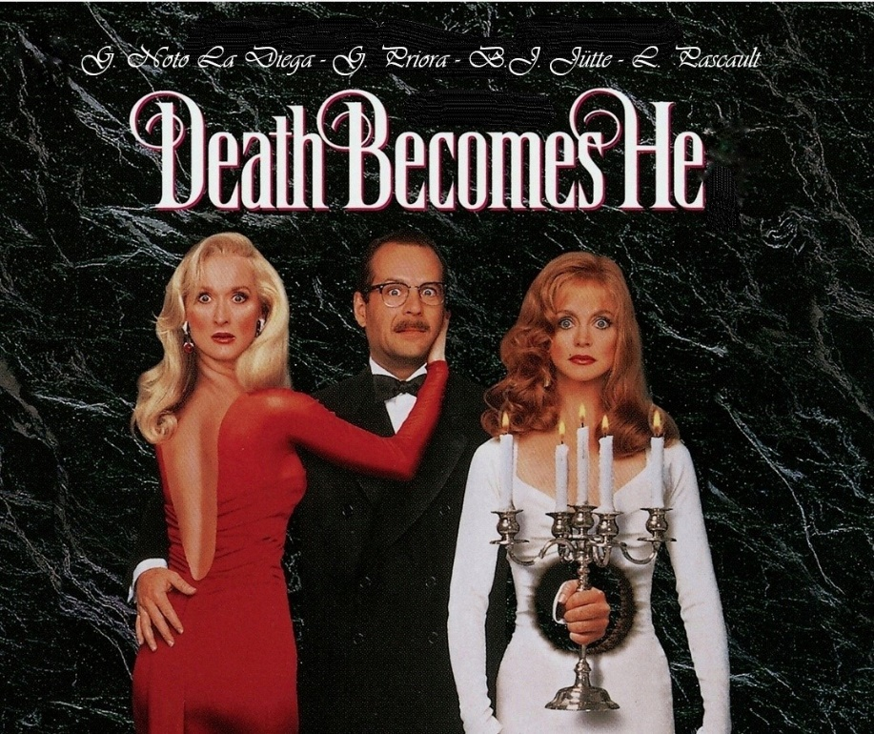

Events organised
On Friday 8th October 2021, the University of Stirling has hosted a Modern Law Review-funded conference on «Are We Owned? A Multidisciplinary and Comparative Conversation on Intellectual Property in the Algorithmic Society» (PI Guido Noto La Diega). Full programme of this hybrid conference with abstracts and bios here. You can also find some videos of the presentations here. The delegates were welcomed by Professor Alison Green on behalf of the University, and the panels were chaired by Dr Mo Egan, Professor William Webster, Professor Richard Haynes, and Professor Rowan Cruft.

Get in touch
If you would like to contribute or suggest anything for future bulletins, please get in touch with Guido.

