ePad FAQs – Practice Assessor/Supervisor

- How do I create an account to access the ePad? To create your account, the student needs to log in through their ePad account first and complete the form “Practice Assessor Allocation” or “Practice Supervisor Allocation” with you. You can view the steps for this in more detail on the video “MyProgress ePad first-time login” on our website here: https://www.stir.ac.uk/about/faculties/health-sciences-sport/study-with-us/studying-nursing/myprogress-epad/ . The Practice Supervisor Allocation form can be completed as many times as required, however the student can only have one Practice Assessor so completing a new Practice Assessor Allocation form will replace the previous version.
- I am unable to complete a form for the student: Some forms within the ePad are only available to certain account types, please refer to the list at the end of this document which details the account types which can complete each form. Also ensure you are opening the form using the “Complete Now” button as shown in the below screenshot, clicking on the form title only opens a preview with no details or previously completed information.
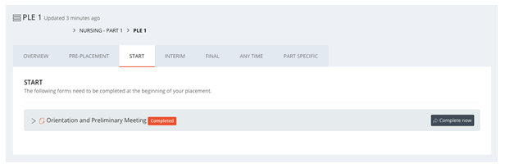
Select the button ‘Complete Form’ to access and complete form.

- I completed information in a form with the student and saved progress, however the information is no longer showing: When filling in forms, progress will only save if ever mandatory field has some text in it; if any are left blank the “Save Progress” button will not work. We recommend students put “TBC” or similar in any fields they cannot yet complete. Also ensure you are clicking the “Complete Now” button as shown above, just clicking the form name only opens a preview which will not show previously entered information.
- I am unable to enter a timesheet and log hours for the student: The first hours logged for a placement need to be done through the student account; after hours have been logged once through the student account for a placement, the PS and PA accounts will be able to log timesheets.
- There is an error in a timesheet logged for the student: Logged timesheets can be amended through the PA and PS accounts; click on the “View Timesheets” icon on the left hand side, click on the entry which needs amended, a box will open where you can amend the number or hours, date etc, then click save. If the entry needs to be deleted, please email epad@stir.ac.uk and we will action this.
- The student has asked me to sign off “Reflective Hours” which they have not spent on placement: Students are entitled to an additional 2.5hours per week in practice to be counted towards practice hours, which is expected to be spent completing their ePad etc. These hours should be logged as the category “University Use Only – University Added Hours” and need to be signed off in the usual way by a PA/PS. The hours should not be recorded for any week the student hasn’t been on placement, for example due to illness. Staff in the University are able to pull reports on the hours logged under this category, so we can monitor this, and correct any errors.
- The student is having trouble logging into their ePad due to phone signal/Wifi access in placement: A mobile app is available for the ePad, which can be used offline and will sync when the device has internet access again.
- The students placement is within a secure ward, where they are unable to bring a mobile device to access their Portal and ePad: Please ask the student to contact us at ePad@stir.ac.uk ; our IS team are working with secure wards to provide students with another way to access their Portal and allow them to log in to their ePad.

Breakdown of which forms can be completed in which accounts:
- Pre-Practice Learning Activities – Student Account Only
- Practice Assessor Allocation – Student Only
- Practice Supervisor Allocation – Student Only
- Orientation and Preliminary Meeting – Student Only
- Learning Development Plan – Student Only
- Interim Feedback Meeting – PA, PS
- Final Assessment – PA only
- Practice Assessor Confirmatory Statement – PA Only
- Patient/Service User/Carer Feedback – Student Only
- Student Reflection on Service User/Care Feedback – Student Only
- Feedback from Additional Learning Opportunities – Student Only
- Additional Notes – All accounts
- Learning Development Support Plan- PA, PS, Tutor, PEF
- Development Support Plan Feedback – PA, PS, Tutor, PEF
- Mandatory Training and Compulsory Practice Skills – Student Only
- Platforms and Proficiencies – PA, PS
- Skills (Annexes A + B) – PA, PS
- Procedures (Annexes A + B) – PA, PS

