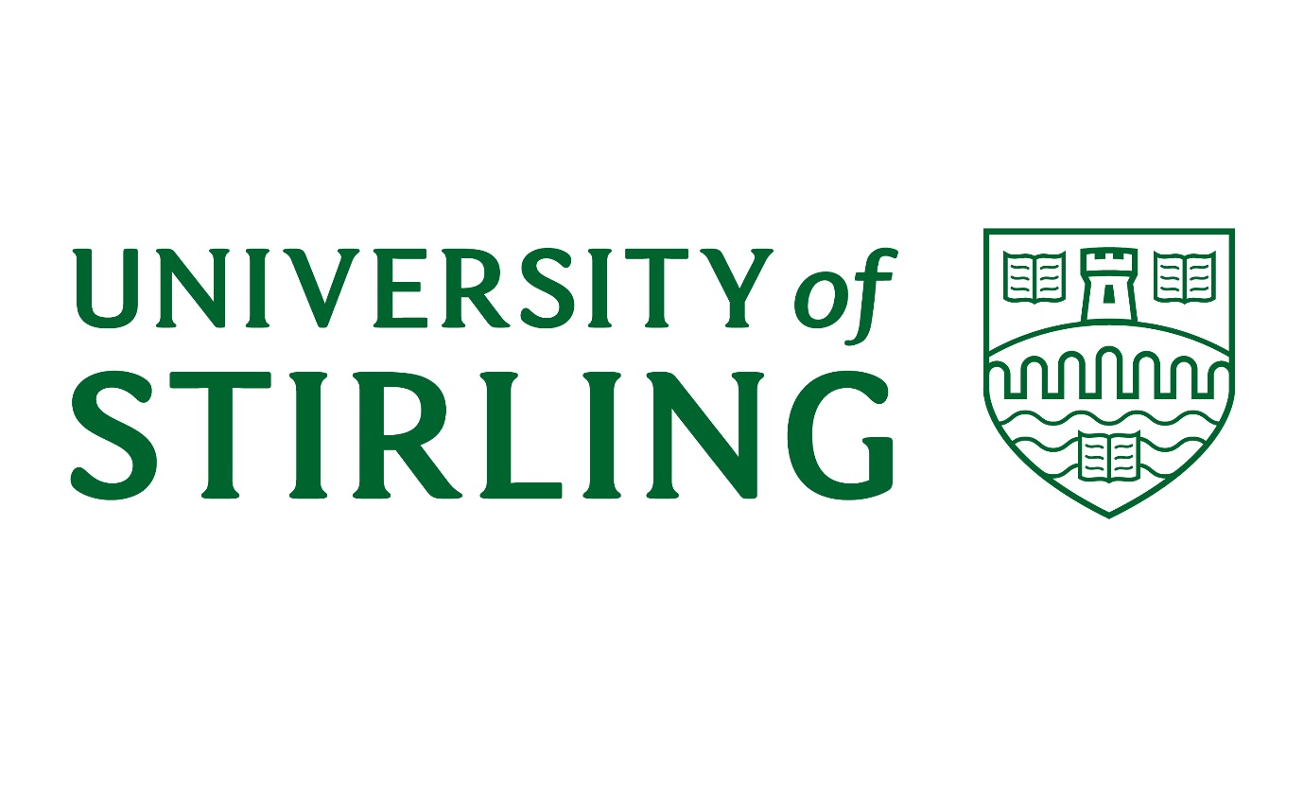

SOCIALLY RESPONSIBLE INVESTMENT POLICY

December 2018

- Introduction

The University of Stirling is committed to ensuring that it makes sound investment decisions that are prudent, responsible and with due integrity.

- Treasury Management Policy Statement

To this end the University maintains a Treasury Management Policy Statement (TMPS), approved by University Court, which sets out the broad financial and risk parameters on which investment activity is to be undertaken. The overall investment strategy specified within the TMPS is that investments are to be made on the basis of achieving competitive interest rates, but balancing that with risk so as to help ensure that security of investment is achieved.

This investment strategy is consistent with good practice guidance issued by the Chartered Institute of Public Finance and Accountancy (CIPFA) which states that the primary purpose of treasury management in public organisations should be the management of risk in relation to capital security, followed by liquidity and yield.

The types of investment instruments that are approved, subject to an assessment of the current risk status, are restricted to:

- Ordinary Current Accounts
- Term Bank deposits
- Certificates of deposit
- Treasury Bills
- Segregated Cash Managers
- Money Funds
- British Government Securities
- Corporate Debt
- Investment Funds

A Socially Responsible Investment Policy (SRIP) has been developed to allow the University to pursue an ethical approach to investment in accordance with the University’s Ethical Code, whilst minimising any potential adverse impact on its investment returns.
The SRIP sits within the over-arching Treasury Management Policy Statement.

- Socially Responsible Investment

The University will use all reasonable endeavours to ensure that it operates its investment policy in a way that is consistent with the aims of its ethical code and its treasury management policy. To achieve those aims, the University will appoint professional advisers and look to those advisors, in the first instance, to use their knowledge and expertise to assist in this process.

The University, for its part, will take all reasonable steps to help ensure that its own procedures fulfil the following aims:

- Invest with organisations whose financial activities include policies and controls to protect communities and local people to prevent human rights abuse and discrimination.

- Invest with organisations whose financial activities include policies and controls to protect the environment to prevent environmental damage, loss of biodiversity and habitats

- Identify investment opportunities in organisations and countries which demonstrate a positive approach to individuals, communities and environmental performance

- Will not invest directly (or through collective funds) in fossil fuel companies, arms companies or corporations complicit in the violation of international law.

- Identify investment opportunities in organisations which are developing environmental technologies to reduce the impacts of polluting/destructive industries and climate change

- To monitor regularly the University’s investments and the procedures for reviewing investment proposals to ensure that its ethical standards are maintained.

- Fund Managers

Where investments are made by third party fund managers the University will ensure that they are aware of this policy and have the expertise and capacity to implement it.

Where the University becomes aware that it directly holds an investment in a company that it considers to be in fundamental breach of acceptable standards of ethical and / or environmental practice, the University will divest the investment in that company as soon as reasonably practicable.

In this regard the University’s fund managers will be subject to periodic review to ensure that this investment policy is being adhered to, and that the service provider represents the best value for money for the University.

If it becomes apparent that an alternative provider may be better placed to provide the fund management services in accordance with the University’s investment objectives, as defined in this policy, then a retendering exercise will be conducted with a view to replacing the provider.

- Review processes

The Socially Responsible Investment Policy will be reviewed as part of the annual review of the Treasury Management Policy.

