On the final page of the online referral form (image below) click on the ‘book appointment now’ button:

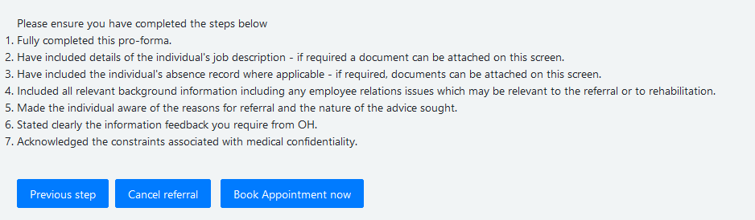

On the next screen, select ‘OHA Management Referral’:
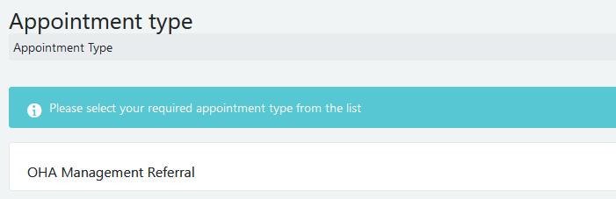

On the next page (image below) we recommend ignoring the filters, and just clicking search. This will bring up all the available appointments.
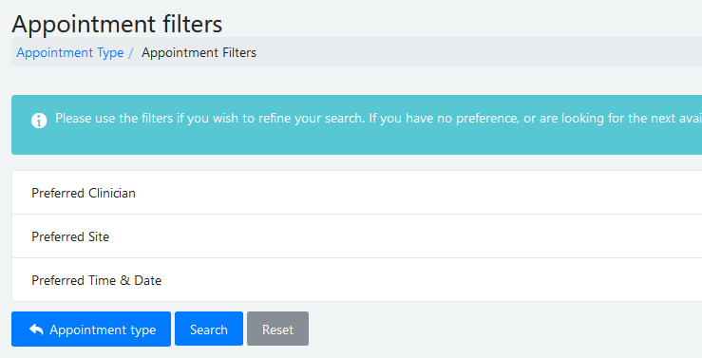

On the results page (image below) scroll through and select the date and time that is best for you (click the appointment to select it):
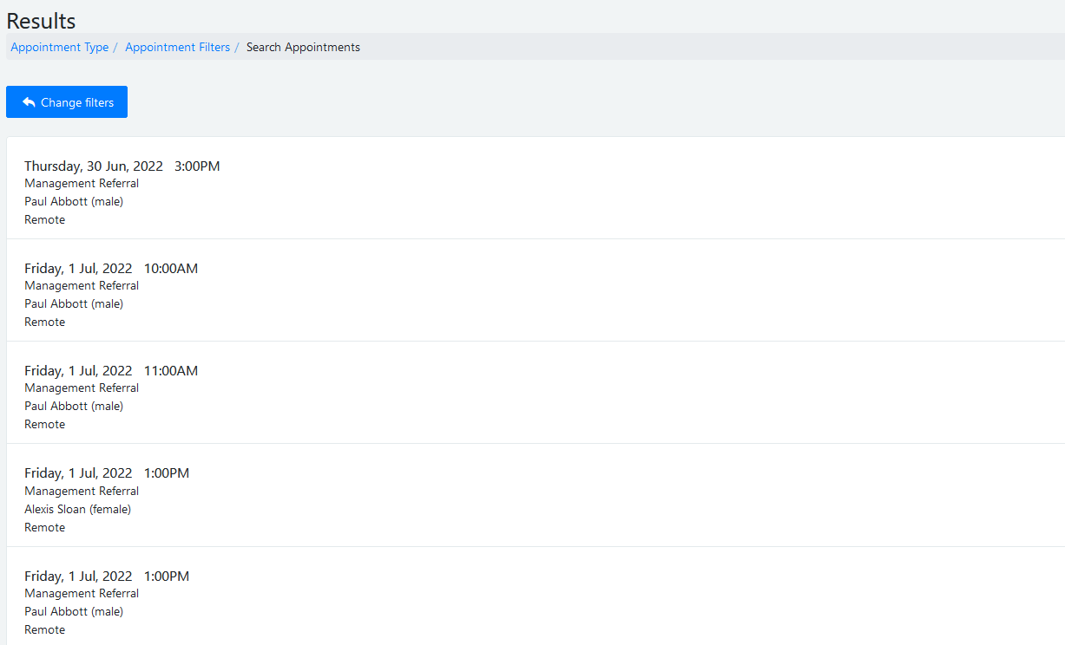

On the next page (image below) click on ‘book appointment’ to confirm the option. Or, if you need to select a different date/time, use the ‘go back’ button and re select an appointment from the list.
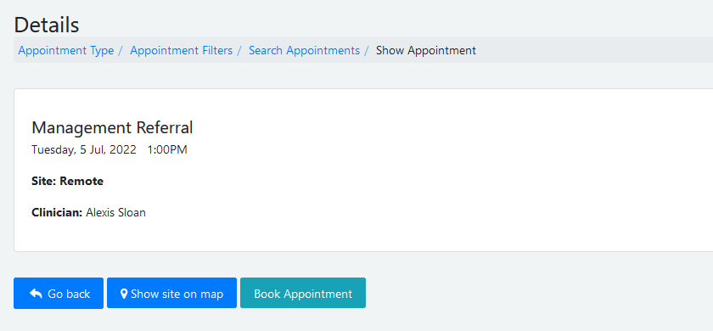

Finally, follow the remaining onscreen prompts to finalise the booking.

What happens next?
Once finalised, a notification is sent to both you, the referrer and to the staff member to confirm the details of the booked appointment.

