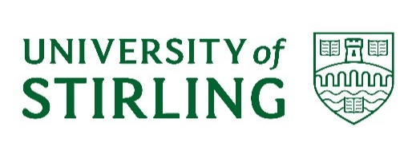
UNIVERSITY COURT

A meeting of the University Court will be held at 2.00 pm on Monday 20 September 2021 in the Court Room. The University Court meeting will be preceded by a tour of the University of Stirling Sports Centre. The timetable for the visit is as follows:

12.00 noon – 1.00 pm Tour of the University of Stirling Sports Centre, meet at the reception to the Sports Centre
1.00 pm – 2.00 pm Lunch, Stirling Court Hotel
2.00 pm – ~4.00 pm University Court meeting in the Stirling Court Hotel

Members unable to attend the Court meeting, and who have not already tendered their apologies, are asked to email: sacsadmin@stir.ac.uk no later than Thursday 16 September 2021.

Eileen Schofield
University Secretary

AGENDA

A starring system is used for the business of the Court. Items which are starred (*) will be discussed and all other items will be noted or approved without further discussion. Any proposals for additional starred items should be submitted to sacsadmin@stir.ac.uk no later than noon on Friday 17 September 2021.

*1. DECLARATIONS OF INTEREST
To note any declarations of interest from Court members, as appropriate

2. MINUTES UC(20/21) Minutes 4
To approve the minutes of the meeting of University Court held on 14 June 2021

3. MATTERS ARISING NOT OTHERWISE ON THE AGENDA
To receive an update on any matters arising from previous minutes

4. REMIT, COMPOSITION AND MEMBERSHIP UC(21/22)1
To note the remit, composition and membership of Court for 2021/22

*5 DEVELOPMENTS IN THE EXTERNAL ENVIRONMENT UC(21/22)2
To note the recent developments in the external environment

INSTITUTIONAL PLANNING AND BUDGETING
*6. INTEGRATED PLANNING AND BUDGETING UC(21/22)3 To consider the integrated plan and budget

*7. ANNUAL PERFORMANCE REPORT UC(21/22)4
To consider the annual performance report

CITY DEAL
*8 CITY DEAL UC(21/22)5
To note the report from the University’s City Region and Growth Deal Programme Board.

GOVERNANCE
*9 ANNUAL REPORT ON INSTITUTIONAL-LED REVIEW UC(21/22)6
To approve the Annual Report on the Institutional Led Review for SFC

POLICY AND PLAN DEVELOPMENTS
*10. BUSINESS TRAVEL AND EXPENSES POLICY UC(21/22)7
To approve the revised travel and expenses policy

*11 STAFF ON CALL POLICY UC(21/22)8
To approve the Staff on Call Policy

*12 RESEARCH CONCORDAT UC(21/22)9
To note progress and alignment to objective following the undersigning of the Concordat to support the career development of researchers

ACTIVITY UPDATES
*13. STUDENTS’ UNION UPDATE UC(21/22)10
To receive an update on activity from the Students’ Union

*14. STAFF AND EMPLOYMENT UPDATE UC(21/22)11
To receive an update on matters relating to staff and employment

COMMITTEE REPORTS
*15. ACADEMIC COUNCIL UC(21/22)12
To consider the report from the meeting of 15 September 2021

RISKS
16. RISKS ARISING Oral
To consider risks associated with any items discussed in the context of the agreed risk appetite statement

OTHER ITEMS
17. ANY OTHER COMPETENT BUSINESS

18. NEXT MEETING
To note that there will be a Court Strategy Day on Friday 29 October 2021 and the next full meeting of Court is scheduled for Monday 13 December 2021.

Policy & Planning
September 2021

