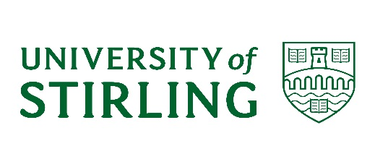
UNIVERSITY COURT

A meeting of the University Court will be held at 2.00 pm on Monday 27 March 2023 in the Stirling Court Hotel. The University Court meeting will be preceded by a presentation from Professor Iain Docherty, Dean of the Institute for Advanced Studies. The timetable for the visit is as follows:

12.00 noon – 1.00 pm Presentation on Institute for Advanced Studies
1.00 pm – 2.00 pm Lunch, Stirling Court Hotel
2.00 pm – ~4.00 pm University Court meeting in the Stirling Court Hotel

Members unable to attend the Court meeting, and who have not already tendered their apologies, are asked to let the Policy & Planning Office (email: sacsadmin@stir.ac.uk) know by no later than Thursday 23 March 2022.

Eileen Schofield
University Secretary

AGENDA

In accordance with the Scottish Code of Good Higher Education Governance, the meeting will be preceded by a meeting of Court members, chaired by the Vice Chair of Court. The Chair of Court and those in attendance will not be present.

1. DECLARATIONS OF INTEREST
To note any declarations of interest from Court members, as appropriate

2. MINUTES UC(22/23) Minutes 2
To approve the minutes of the meeting of University Court held on 12 December 2022

3. MATTERS ARISING NOT OTHERWISE ON THE AGENDA
To receive an update any matters arising from previous minutes

4. KEY DEVELOPMENTS IN THE EXTERNAL ENVIRONMENT UC(22/23)29
To receive an update on recent developments in the external environment

PLANNING AND BUDGETING

5. QUARTER 2 PERFORMANCE REPORT UC(22/23)30
To consider the Quarter 2 report

6. CAPITAL AND MAJOR INFRASTRUCTURE PLAN UC(22/23)31
To approve the updated Capital and Major Infrastructure Plan, Quarter 2 2022/23

7. CITY DEAL UC(22/23)32
To consider the report from the University’s City Region and Growth Deal Programme Board

8. DEVELOPMENT OF THE STRATEGIC PLAN UC(22/23)33
To consider an update on development of the Strategic Plan.

GOVERNANCE

9. PUBLIC SECTOR EQUALITY DUTY UC(22/23)34
To approve the report on mainstreaming equality including gender pay gap information for publication in April 2023.
ACTIVITY UPDATES

10. STUDENTS’ UNION UPDATE UC(22/23)35
To receive an update on activity from the Students’ Union

11. STAFF AND EMPLOYMENT UPDATE UC(22/23)36
To receive an update on matter relating to staffing and employment

COMMITTEE REPORTS

12. ACADEMIC COUNCIL UC(22/23)37
To consider the report from the meeting of 8 March 2023

13. JOINT POLICY, PLANNING & RESOURCES COMMITTEE UC(22/23)38
To consider the report from the meeting of 28 February 2023.

14. AUDIT COMMITTEE UC(22/23)39
To consider the report from the meeting of 6 February 2023

15. GOVERNANCE AND NOMINATIONS COMMITTEE UC(23/23)40
To consider the report from the meeting of 24 January 2023

RISKS

15. RISKS ARISING Oral
To consider risks associated with any items discussed in the context of the agreed risk appetite statement.

OTHER ITEMS
16. ANY OTHER COMPETENT BUSINESS

17. NEXT MEETING
To note the next full meeting of Court is scheduled for 12 June 2023.

