BUILDING A MOVEMENT:
Community Development and Community Resilience in Response to Extreme Events

POLICY BRIEF
DECEMBER 2019

Context
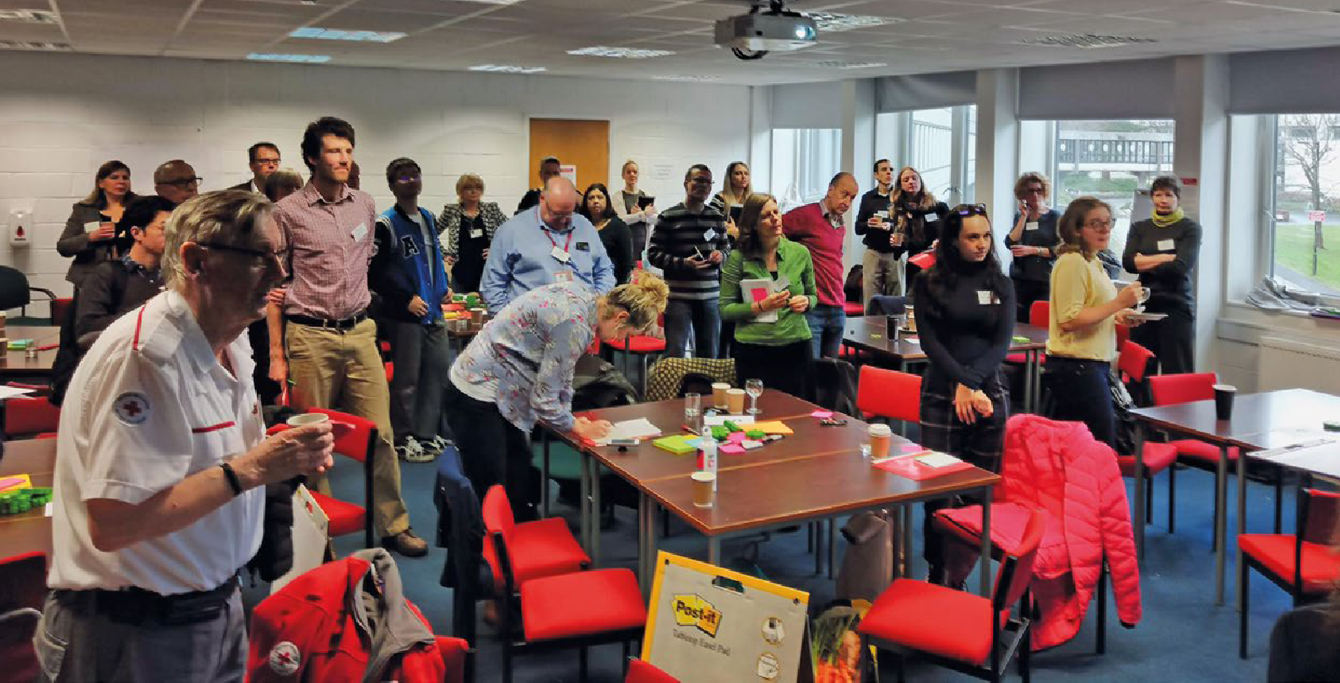There are gaps in understanding what community resilience is and means to those working in communities, academia, practice and policy and how it is currently enacted in Scotland. Greater understanding of existing experiences can be used to encourage development of community resilience. By enhancing resilience, those affected by extreme events are better able to cope; communities are given a voice; and risk and vulnerability on local, national and global scales are reduced.

MEMORY
Experience and shared memory
CONNECTIONS
Social ties and connections
SHARING
Leadership, engagement and shared responsibility
MINDSET
Mindset, collective thinking, openness to adapt and cultural change
DIVERSITY
Integration, inclusivity, equity and diversity
COMMUNICATION
Communications, social support and co-ordination
TRAINING
Training and exercises, and identifying local needs

The project
Funded by Scotland’s National Centre for Resilience and delivered by University of Stirling as part of Extreme Events in Science and
Society’ research programme (extremeevents.stir.ac.uk) the project explored the ways communities and individuals, both locally and internationally, are impacted by and react to extreme events and how community resilience is manifested.
It brought together over 80 participants from 45 organisations and groups in Scotland with insights from communities, the voluntary sector, academia
and statutory organisations. It centred around two participative workshops, a series of semi-structured interviews with a subset
of participants, a photo exhibition and writing journals.

This document sets out key insights from the approach and key messages relevant for policy and practice.

A full report is available at: https://extremeevents. stir.ac.uk/projects/ building-a-movement-
community-development- and-community-resilience- in-response-to-extreme- events/
Key insights in relation to building community resilience
- Extreme events in Scotland. Extreme events that impact Scotland were identified and included pandemics (such as flu outbreaks), collapses in biodiversity, mega events (such as major sporting events like the Commonwealth Games) and economic events (such as
factory closures resulting in large job losses). However, the core extreme events that Scotland is currently facing were considered to be flooding and other major weather events, as well as major political events such as Brexit and Scottish Independence. It is important to build understanding
of the key risks to communities to be in a better place to respond.

Key components of resilient communities.
The project identified seven main themes that are featured within resilient communities as shown in the figure.

A key element of community resilience is experience and shared memory. Whilst there is already evidence and local
knowledge of the importance of shared identities and community attachments to places, less is known about the differences between urban and rural resilience, the dynamics of establishing a shared narrative and the temporality of resilience. There is a need for longitudinal evidence and long term research and a recognition that there
is a temporal ebb and flow to community resilience.

Support years not months

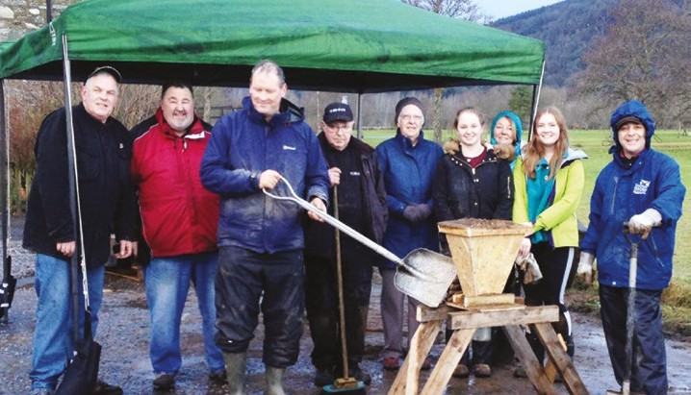
We are missing proper engagement to ensure wider representation, how do we

support the most marginalized in society?

Formal and informal development and processes are needed to build community resilience.
Informal development can include things such as ensuring local community events are supported, these events could also include elements of activism and promote a
sense of ownership. Formal development requires
clear roles, plans and communication strategies are in place as well as training and equipment. Commitment from the community and
the local authority to work together towards a common goal is crucial.

Key recommendations
- Ensure there is physical space for community groups to share their experiences, memories and knowledge. There is need for the creation, or maintenance, of sustainable community centres that can be used to hold meetings, events and provide space where the community can develop
their identity. These spaces do not have to be built from the ground up, but instead can be repurposed buildings or can be created by partnering with local businesses that are interested in utilising their existing space in
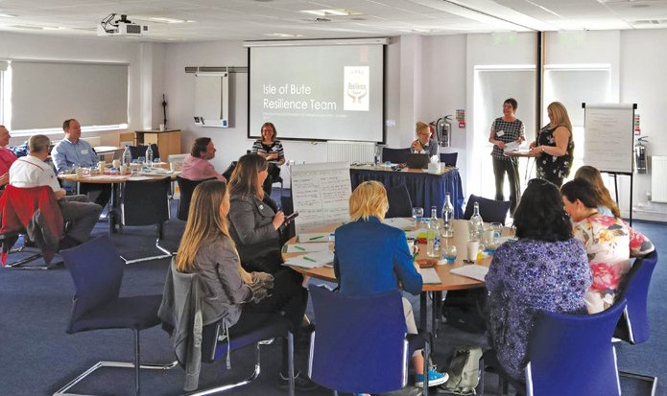
creative ways. These spaces can be subsidised by the local authority but the community needs to have autonomy and ownership as to how the location is used.

Continue to utilise, support and promote local community knowledge.
Each community has different needs, resources and experiences and we need to encourage and nurture relationships between researchers, policy makers and communities in order to identify what these are and how they
can be best utilised to build resilient communities. Helping communities identify their shared identity and collective narratives is key to fostering long-term, sustainable resilience. This can be facilitated through the co-production of knowledge exchange workshops, or citizen hearings, with local community members, policy makers (such
as has been demonstrated in this project) and co-production of research that includes community and policy stakeholders from the start. It is essential to hear the lived-experience of community members and for researchers and policy-makers to value this kind of evidence and incorporate it into research and policy.

Care is a fundamental factor in the idea of a community

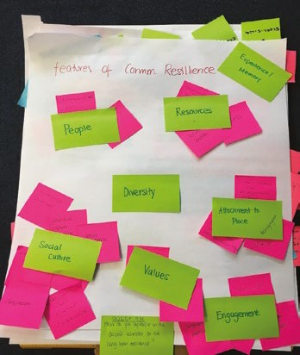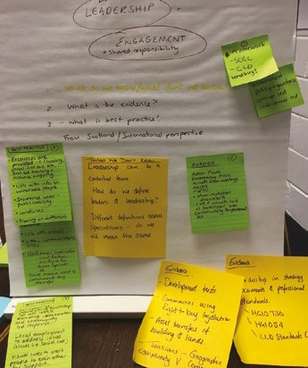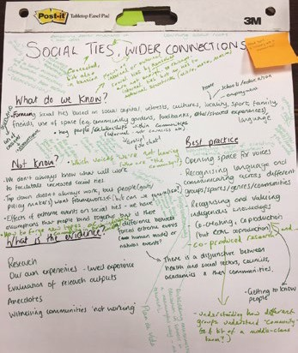

- Enable co-production of community projects from the beginning. This includes involvement of local community members,
policy makers and other key individuals or organisations that are identified as important to the community. The success of this project and the case studies we heard from would not have been possible without the diversity and engagement of community members from the beginning, working in collaboration with a variety of stakeholders and partners.

Create foundations for good communication and partnership working.
If there are local and regional resilience partnerships in place, local communities need to be aware of who
are in these partnerships, what their role is and how to contact them. Partnerships could actively engage in supporting the development of social capital and
community resilience before an extreme event takes place. There is a need for improved working, communication and collaboration between formal resilience groups linked to local authorities and Scottish Government with those more informal community networks which may often develop organically, particularly after extreme events.

The project team gratefully acknowledge the insight of all participants and speakers, and in particular the community case studies, namely

- Sustaining Dunbar
- The Garioch Partnership
- The Isle of Bute Resilience Team
- Braemar Care and
- Eden Project Communities

For more information see the full report https://extremeevents. stir.ac.uk/projects/building- a-movement-community-

development-and-community- resilience-in-response-to- extreme-events/

The value of this project
Through building a narrative of experiences this project has contributed to a greater understanding of community resilience, to form the foundations for sustainable, positive changes in people’s lives and communities. The
project created opportunities to explore the ways communities and individuals, both locally and internationally, are impacted by and react to extreme events.
It considered existing policy, practice, legal and conceptual systems/frameworks that engage and work with communities to promote resilience.

Sustainable charity Sniffer co-facilitated the workshops.

Contact Details
Website: www.extremeevents.stir.ac.uk (includes a ‘contact us’ form on the home page)
Twitter: @StirExtreme
Project Lead: Dr Sandra Engstrom, University of Stirling, sandra.engstrom@stir.ac.uk

